**GETTING INSIGHTS OUT OF INDIAN STARTUP CULTURE**

Dataset -: <https://www.kaggle.com/sudalairajkumar/indian-startup-funding>

Resources: - <https://pandas.pydata.org/pandas-docs/stable/index.html> and <https://seaborn.pydata.org/>

Goal Statements-:

# The important investor of the Indian ecosystem

# The pattern of fundings does start up generally gets in India

# Various sectors or industries which are more favoured by investors for funding

# How funding has changed overtime

# Angel Investors of India

# Max and Min investment out of all start-ups in India

**Output:-**

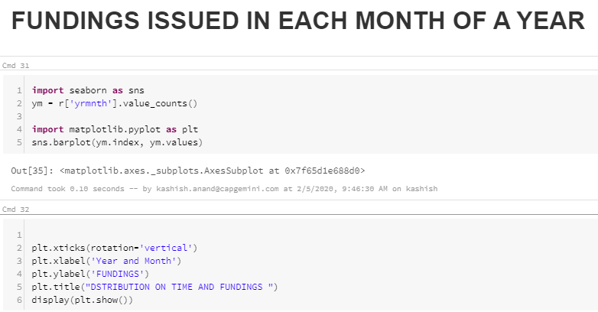

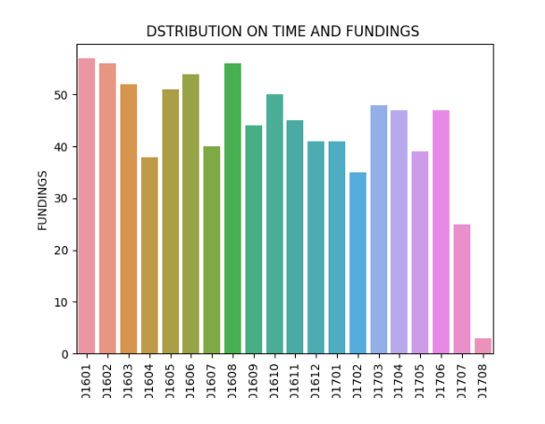

**Start-ups which get funded more than one time**

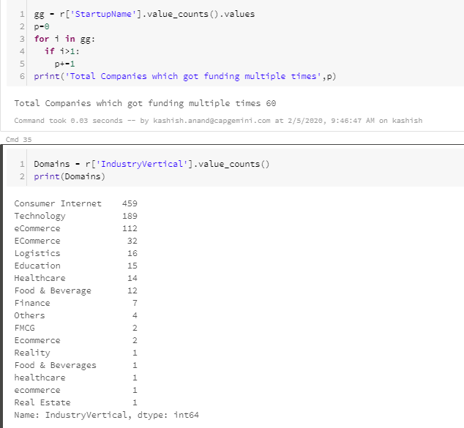

For the plotting purpose I’m using seaborn Library and Pandas for all actions and transformations.

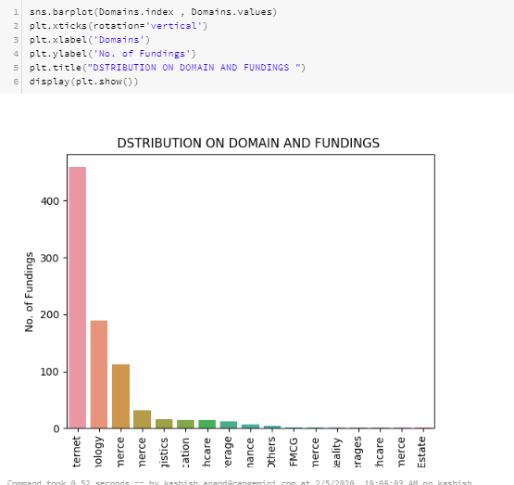

Insight - Maximum start-ups were based on Consumer Internet.

**Maximum Start-ups based on Cities**

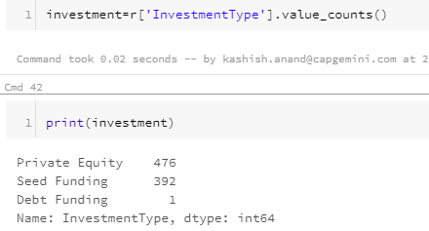

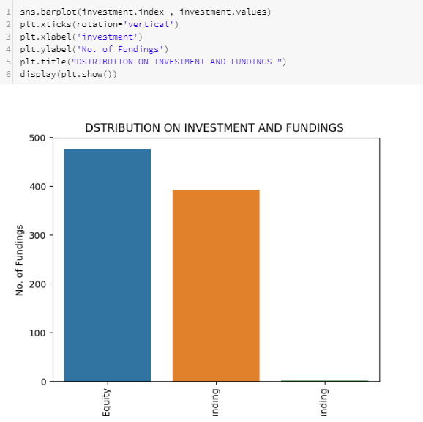

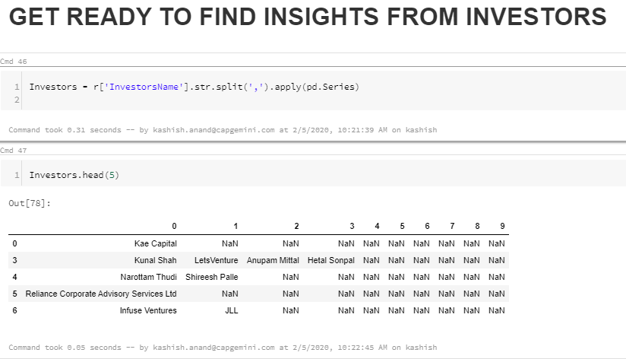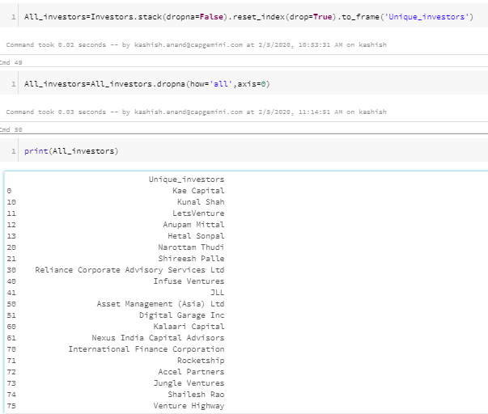

Quite Interesting....  
We got the list of all investors who are investing in INDIAN STARTUPS

**Angel Investors**

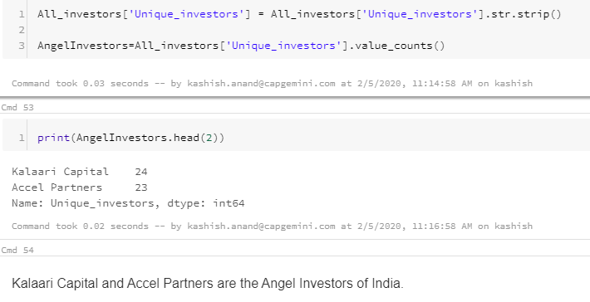

# LET's SEE THE TECHNOLOGY TREND IN THE STARTUP MARKET

